**Name = Mohmadniwal Gavandi**

**Sr. No. = 45**

**1. Discuss the prototyping model. What is the effect of**

**designing a prototype on the overall cost of the**

**project?**

Ans = The prototyping model is a systems development method in which a prototype is built, tested and then reworked as necessary until an acceptable outcome is achieved from which the complete system or product can be developed.

Prototyping may have some initial costs of developing, but it reduces the overall budget by helping your product to be free of the errors or glitches that could have occurred if the idea was made from scratch without any prior user testing. Furthermore, prototyping also helps to understand the intrinsic flaws, shortcomings and drawbacks that can be improved during the product development process. If the prototyping process is ignored completely, it might result in the restructuring and redesigning of the entire product after spending all your resources on its development. So, the effect of designing a prototype on the overall cost of a software project is to actually reduce the additional costs of restructuring and reframing it after its full-fledged development- which might cost a fortune.

**2. Compare iterative enhancement model and**

**evolutionary process model.**

Ans = Iterative Enhancement Model: This model has the similar phases as the waterfall model, but with fewer restrictions. In general the phases occur in the same order as in the waterfall model but these may be conducted in several cycles. A utilizable product is released at the end of the each cycle with each release providing additional functionality.

Evolutionary Development Model: Evolutionary development model bear a resemblance to iterative enhancement model. The similar phases as defined for the waterfall model occur here in a cyclical fashion. This model is different from iterative enhancement model in the sense that this doesn't require a useable product at the end of each cycle. In evolutionary development requirements are implemented by category rather than by priority.

**3. As we move outward along with process flow path of**

**the spiral model, what can we say about software**

**that is being developed or maintained.**

Ans = The product advances to a more complete state as work spirals outward, and the **level of abstraction at which work is conducted decreases** (i.e., implementation specific work accelerates as we move further from the origin).

**Explanation:**

One of the most significant models for the **Software Development Life**Cycle that supports **risk handling** is the**spiral model**.

In diagrammatic form, it resembles a **spiral with several loops**. The spiral's precise number of loops is unclear and varies from project to project. A phase of the software development process is referred to as each **spiral loop.**

The project manager might alter the precise number of phases required to build the product depending on the project's risks. The project manager plays a crucial role in the spiral model of product development since they dynamically set the number of phases.

The **waterfall model's** methodical, managed elements are combined with the idea of iterative development in the**spiral model.** Iterative and sequential linear development models, or the waterfall model, are combined to create the spiral model, which places a strong emphasis on risk analysis.

**4. Explain the Scrum Agile methodology.**

Ans = Agile scrum methodology is a project management system that relies on incremental development. Each iteration consists of two- to four-week sprints, where the goal of each sprint is to build the most important features first and come out with a potentially deliverable product.

Scrum methodology - Scrum methodology is based on a set of very defined practices and roles that must be involved during the software development process. It is a flexible methodology that rewards the application of the 12 agile principles in a context agreed by all the team members of the product.

Agile methodology - The Agile methodology is a way to manage a project by breaking it up into several phases. It involves constant collaboration with stakeholders and continuous improvement at every stage. Once the work begins, teams cycle through a process of planning, executing, and evaluating.

**5. Explain the utility of Kanban CFD reports.**

**Ans =** The cumulative flow diagram (also known as CFD) is one of the most advanced Kanban and Agile analytics charts. It provides a concise visualization of the three most important metrics of your flow:

* + Cycle time
  + Throughput
  + Work in progress

Its main purpose is to show you how stable your flow is and help you understand where you need to focus on making your process more predictable. It gives you quantitative and qualitative insight into past and existing problems and can visualize massive amounts of data.

# How To Read a Cumulative Flow Diagram

The chart tracks the total number of work items in the columns of the "In Progress" section on your Kanban board each day.

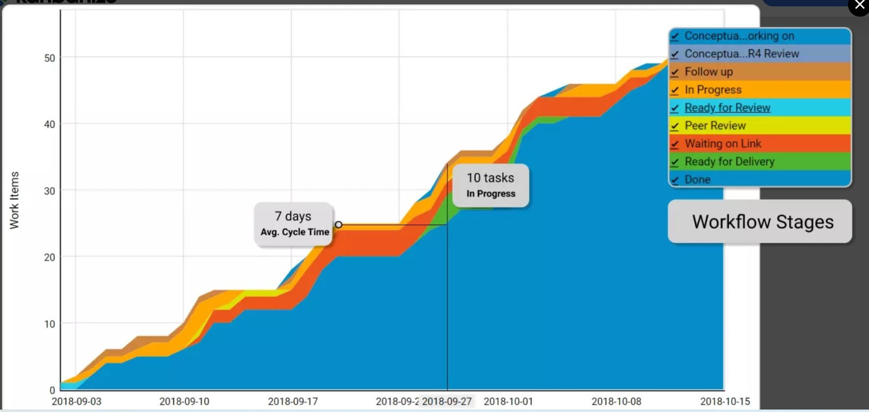

The horizontal axis of the CFD represents the time frame for which the chart is visualizing data. The vertical axis shows the cumulative number of cards in the workflow at various points in time.

The differently colored bands that divide sections of the upward flow are the different stages of your workflow as they appear on the Kanban board itself. The bands always go up or sideways in accordance with the number of assignments that go through your process.

The top line of each band on the cumulative flow chart represents the entry point of tasks in the respective stage of your Kanban board, while the bottom one shows when it leaves it. If a line becomes flat, nothing arrives in the corresponding stage, or nothing is leaving it.

Using a CFD, you can get an idea of how long your tasks' approximate cycle time is. This is possible by measuring the horizontal distance between the top line of the first stage on the cumulative flow diagram and the bottom line of the last "in progress" stage.

The number of days/weeks/months that have passed is the approximate average cycle

time of your team’s assignments for the time frame.

The distance between the lines of a CFD will show you the problems of your workflow.

# Understanding the data on a CFD Chart

You can spot whether your process is stable in just a single glance by looking at how the top and the bottom line of each band in your cumulative flow diagram are progressing.

There are three common scenarios:

* 1. The Bands are Progressing in Parallel

This means that your throughput is stable, and new tasks are entering your workflow in parallel to those that are leaving it. This is the ideal outcome and shows that you can focus your efforts on shortening your assignments' cycle times.

1. A Band is Rapidly Narrowing

If a band on your CFD is continuously narrowing, that means that the throughput of the stage it represents is higher than the entry rate. This is a sign that you’ve got more capacity than you really need at this stage, and you should relocate it to optimize the flow.

1. A Band is Rapidly Widening

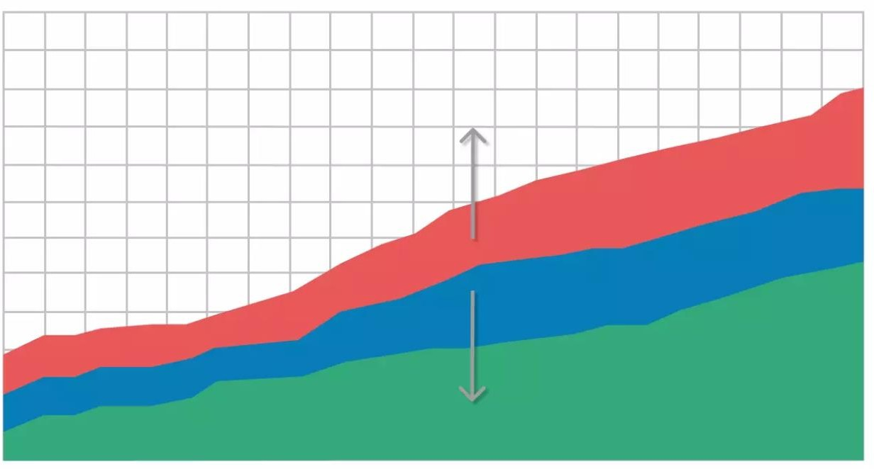

Whenever this happens on a cumulative flow diagram, the number of cards that enter the corresponding stage on the Kanban board is higher than the number of assignments leaving it. It is a common problem caused by multitasking and other waste activities that don’t generate value.

There are many possible actions to resolve this issue. However, if this is not generated by a dependency on external stakeholders, you should reconsider the existing WIP limits on your Kanban board and focus on finishing tasks that are in progress before starting new ones.